**PooPooPiPe Art Style Guide**

1. **Backgrounds**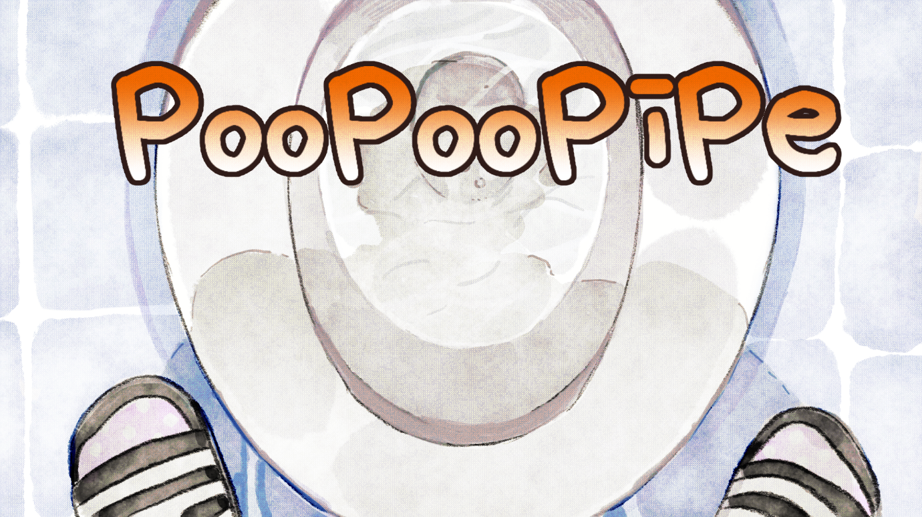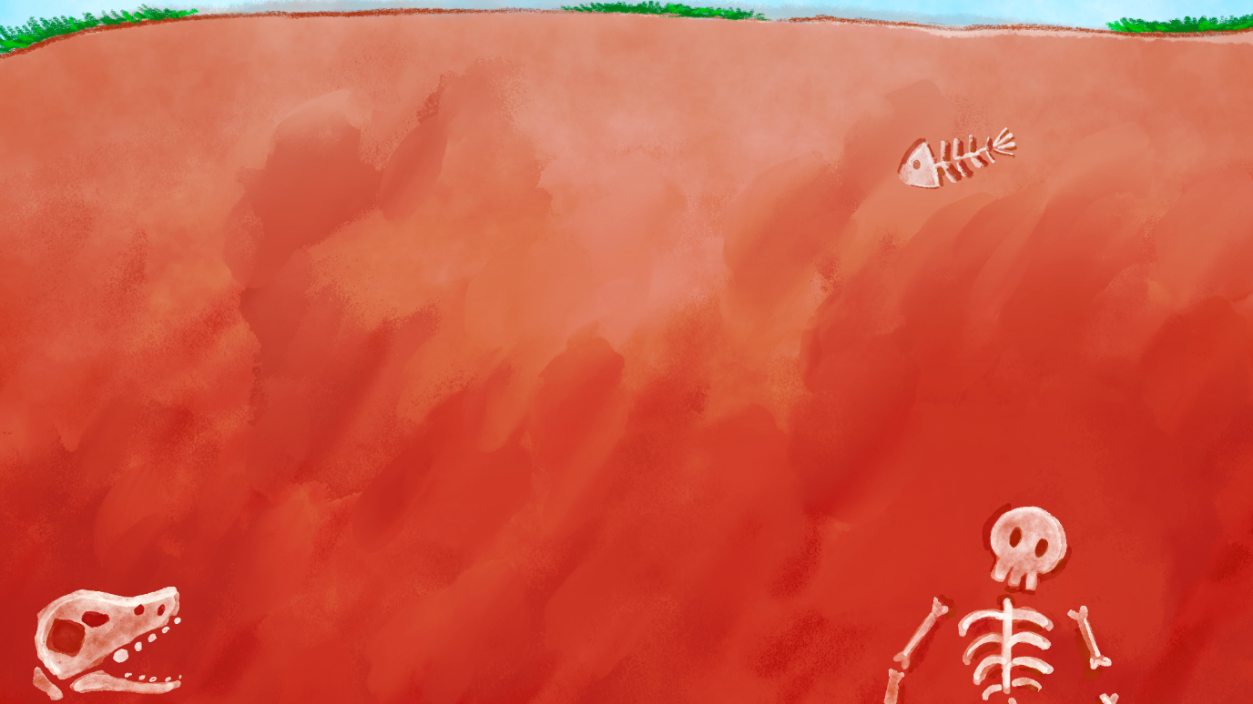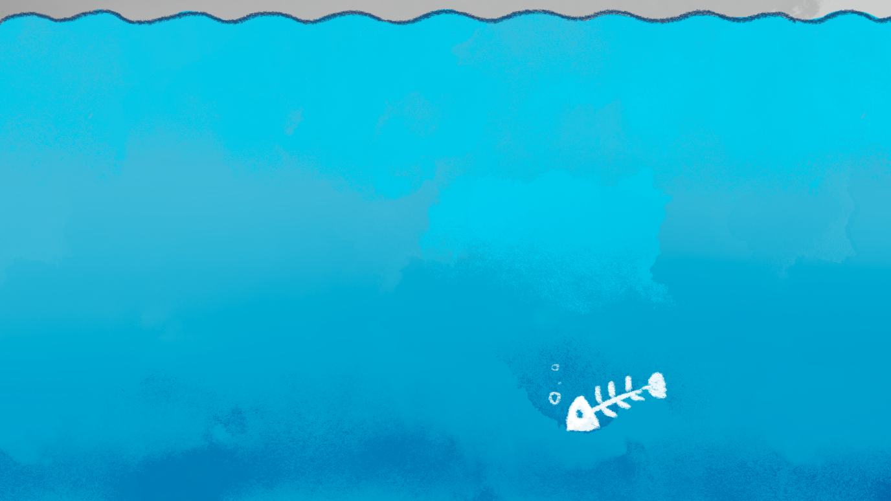

The backgrounds of the game are used a style of ‘water paint’. The reason why changing the art style was to give a bit softer view of our game. At the first time, we wanted to appeal our game overall joyful atmosphere. However, the colors were too strong for the players, which made them tired. Therefore, also considering the phases changing during the game, we decided to change the background style. Of course, this is a huge change. Therefore, we needed to change the UIs and the other artworks either.

1. **Pipes / User Interfaces used in game itself.**

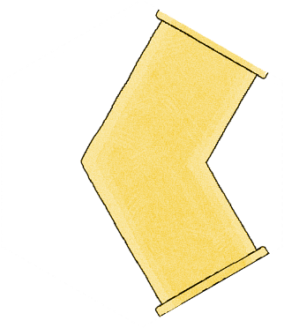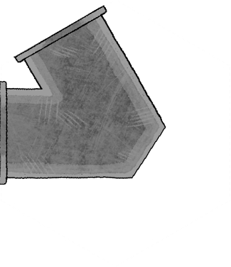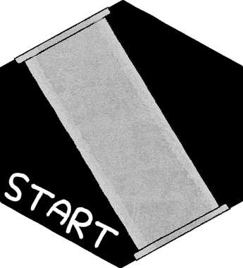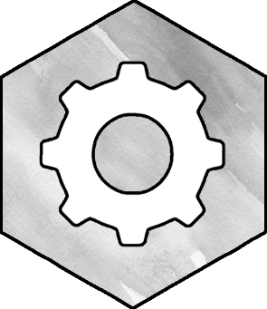

The pipes were necessary to be changed too. Even though we changed the atmosphere of the artworks, the main theme ‘analogue’ and ‘soft’ is remained. Therefore, for the unity of the overall graphics, the pipes are colored like water paint drawings too.

1. **Cutscenes**

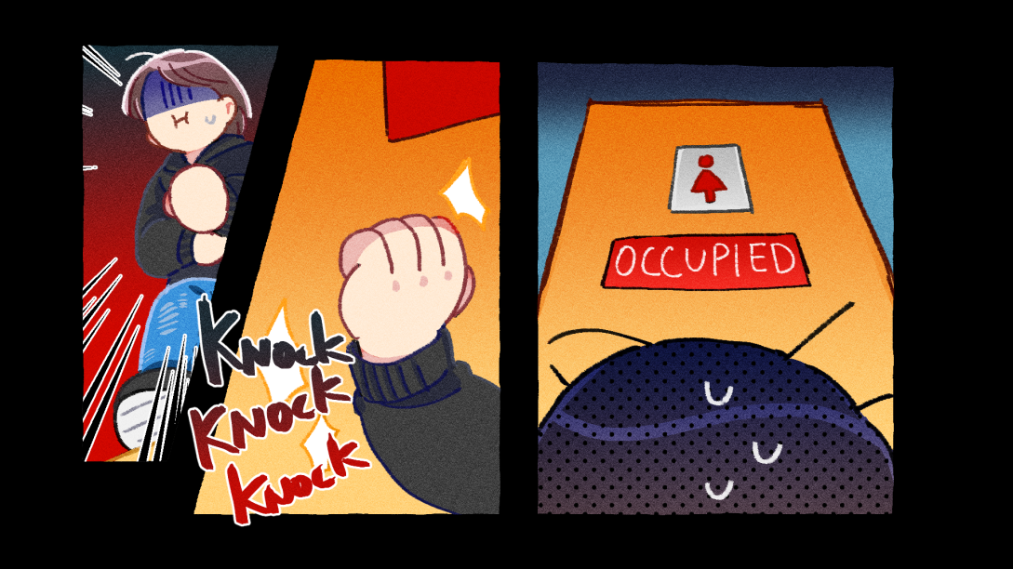

Different from the game itself, the cutscenes are drawn ‘cartoon’ style. The reason why is that it needs to describe a simple story, separating with the game. Therefore, matching the ‘childish’ theme of our game, the graphic style of the cutscenes are matched ‘cartoon’ style, which has bright, strong colors, with several cuts, and sound effect text.

1. **Texts used in games.**

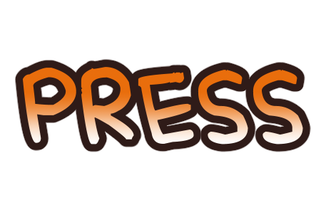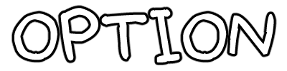

As keep emphasizing that our game overall graphic styles are ‘analogue’, the text used in game (level description, tutorial, main menu buttons, etc.) are also used copyright free font which is ‘analogue’, ’hand-written’ style. The font used in game a\has a goofy expression, which pretty much matches to our game theme, poo. The color of some texts are matched similar to the main characters ‘poo’ color for unity.